DATA ANALYTICS INTERNSHIP PROJECT REPORT
Executive Summary
This project was completed as part of the ApexPlanet Data Analytics Internship Program using the Superstore Sales Dataset. The objective was to analyze sales performance, customer behavior, product profitability, and regional business trends through data analytics techniques.
The project included data cleaning, exploratory data analysis (EDA), SQL-based data extraction, dashboard creation, statistical analysis, customer segmentation, predictive modeling, and workflow automation.
Dataset Description
The Superstore Sales Dataset contains information related to orders, customers, products, sales, profit, regions, and shipping details.
Tools Used
- Python
- Pandas
- NumPy
- Matplotlib
- Seaborn
- SQL
- Power BI
- Scikit-learn
- Jupyter Notebook
Dashboard
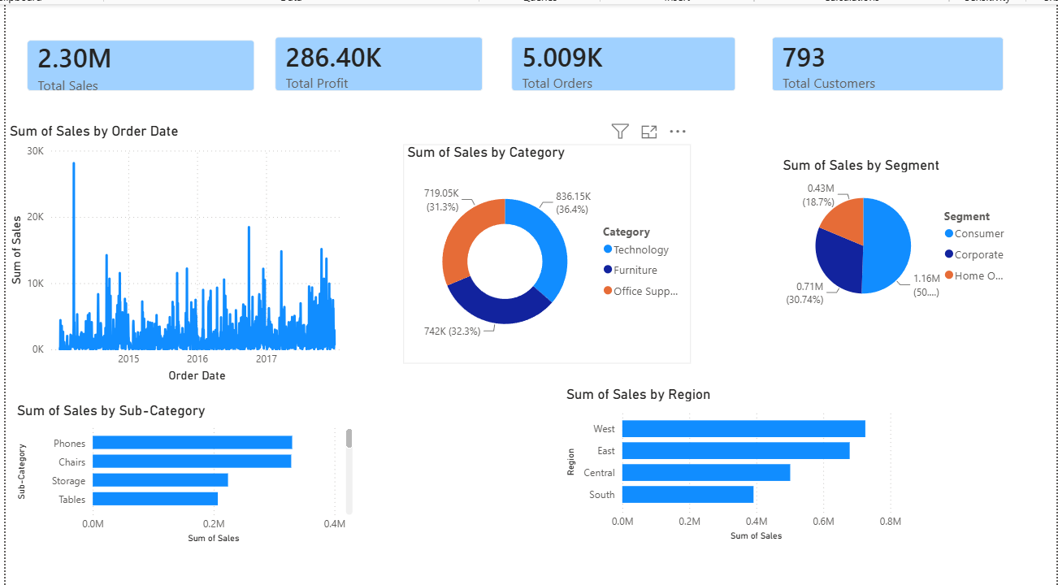

Key Insights
1. Technology Category Generated the Highest Sales
Technology products contributed the highest overall sales revenue.
2. West Region Performed Best
The West region consistently achieved strong sales and profit.
3. High Sales Do Not Always Mean High Profit
Some products generated high sales but low profitability.
4. Customer Spending Is Concentrated
A small group of customers contributed a large share of revenue.
5. Seasonal Trends Exist
Sales patterns showed fluctuations throughout the year.
Business Recommendations
Recommendation 1
Increase focus on Technology products.
Recommendation 2
Improve margins on low-profit products.
Recommendation 3
Implement loyalty programs for high-value customers.
Conclusion
The project successfully transformed raw data into meaningful business insights through data analytics and visualization techniques.

